SIMATS ENGINEERING
ASSESSMENT TOOL 1

COURSE NAME: CSA1612 COURSE CODE: Data Warehousing and Data Mining

COURSE OUTCOME COVERED

CO1: Design data warehouse architectures with appropriate dimensional models for effective decision support systems. BL1,BL2
Assessment Tool Weightage: 40%

QUESTIONS: 4 Total Marks:20

Annexure A
SHORT ANSWER TEST

Criteria | Conceptual Understanding(3) | Accuracy of Answer(2.5) | Application of Knowledge(2) | Completeness of Response(1.5) | Clarity & Presentation(1) | Total(10)
Weightage | 30% | 25% | 20% | 15% | 10% | 100%
Q1
Q2
Q3
Q4

Code of Conduct:

I ____________________ (Name / Reg No) certify that this submission is my original work and that I have adhered to the guidelines specified for this assessment.
I understand that any violation of academic integrity rules will result in disciplinary action.

Signature of the student:

RUBRICS FOR CALCULATION

Criteria | Weightage | Level 4 – Exemplary (5 Marks) | Level 3 – Proficient (4 Marks) | Level 2 – Developing (2–3 Marks) | Level 1 – Beginning (0–1 Mark)
Conceptual Understanding | 30 | Demonstrates clear and complete understanding of the concept | Good understanding with minor gaps | Basic understanding with some misconceptions | Poor or incorrect understanding
Accuracy of Answer | 25 | Completely correct answer with no errors | Mostly correct with minor errors | Partially correct with noticeable errors | Incorrect or irrelevant answer
Application of Knowledge | 20 | Correctly applies concepts to solve the question/problem | Applies concepts with minor mistakes | Limited or partially correct application | No or incorrect application
Completeness of Response | 15 | Covers all required parts of the question | Covers most parts with minor omissions | Covers only some parts | Incomplete or missing response
Clarity & Presentation | 10 | Clear, concise, and well-organized answer | Understandable with minor issues | Somewhat unclear or poorly structured | Difficult to understand

Annexure A
Short Answer Test

1.Suppose that a data warehouse consists of the three dimensions time, doctor, and patient, and the two measures count and charge, where charge is the fee that a doctor charges a patient for a visit.
(a) Enumerate three classes of schemas that are popularly used for modeling data warehouses.
(b) Draw a schema diagram for the above data warehouse using one of the schema.
(c) To obtain the same list, write an SQL query assuming the data is stored in a relational database with the schema fee (day, month, year, doctor, hospital, patient, count, charge).
(5 Marks)

2.Suppose that a data warehouse for Big University consists of the following four dimensions: student, course, semester, and instructor, and two measures count and avg grade. When at the lowest conceptual level (e.g., for a given student, course, semester, and instructor combination), the avg grade measure stores the actual course grade of the student. At higher conceptual levels, avg grade stores the average grade for the given combination. (5 Marks)
(a) Draw a snowflake schema diagram for the data warehouse.
(b) Starting with the base cuboid [student,course, semester,instructor], what specific OLAP operations
(e.g., roll-up from semester to year) should one perform in order to list the average grade of CS courses
for each Big University student.
(c) If each dimension has five levels (including all), such as “student < major < status < university < all”, how many cuboids will this cube contain (including the base and apex cuboids)?
3.Design a data warehouse for a regional weather bureau. The weather bureau has about 1,000 probes, which are scattered throughout various land and ocean locations in the region to collect basic weather data, including air pressure, temperature, and precipitation at each hour. All data are sent to the central station, which has collected such data for over 10 years. Your design should facilitate eﬃcient querying and on-line analytical processing, and derive general weather patterns in multidimensional space. (5 Marks)

4. A data cube, C, has n dimensions, and each dimension has exactly p distinct values in the base cuboid. (5 Marks)
Assume that there are no concept hierarchies associated with the dimensions.
(a) What is the maximum number of cells possible in the base cuboid?
(b) What is the minimum number of cells possible in the base cuboid?
(c) What is the maximum number of cells possible (including both base cells and aggregate cells) in the
data cube, C?
(d) What is the minimum number of cells possible in the data cube, C?

Question 1. Data Warehouse: Time, Doctor and Patient
Given:
• Dimensions: Time, Doctor, Patient
• Measures: count and charge
• charge = fee charged by a doctor for a patient visit.
1(a). Three popular data warehouse schemas
The three commonly used schemas are:
1. Star Schema – One central fact table is connected directly to several dimension tables. It has a simple structure and supports fast querying.
2. Snowflake Schema – A normalized form of the star schema in which dimension tables are further divided into related tables. It reduces redundancy.
3. Fact Constellation Schema – Contains multiple fact tables sharing dimension tables. It is useful for large and complex data warehouses.
Therefore: Star Schema, Snowflake Schema, and Fact Constellation Schema.

1(b). Schema diagram – Star Schema
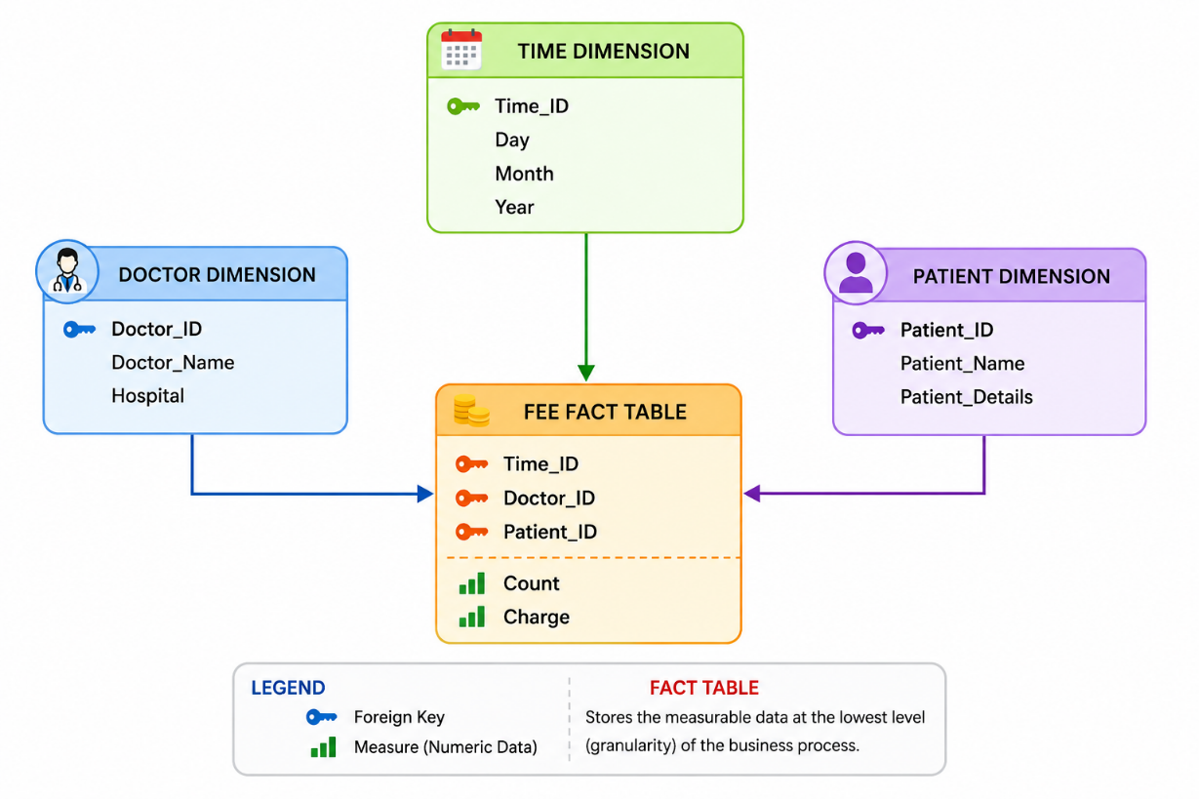The Fee Fact Table stores the numerical measures Count and Charge. The Time, Doctor, and Patient tables provide descriptive information. Since one fact table is surrounded by dimension tables, this is a Star Schema.

1(c). SQL query
SELECT
day,
month,
year,
doctor,
hospital,
patient,
SUM(count) AS total_visits,
SUM(charge) AS total_charge
FROM fee
GROUP BY
day,
month,
year,
doctor,
hospital,
patient;
SUM(count) calculates the total number of visits, SUM(charge) calculates the total fee, and GROUP BY produces a summary for each combination of time, doctor, hospital, and patient.

Question 2. Big University Data Warehouse
Given dimensions: Student, Course, Semester, Instructor. Measures: count and avg grade. At the lowest level, avg grade stores the actual course grade. At higher levels, it stores the average grade.
2(a). Snowflake schema diagram
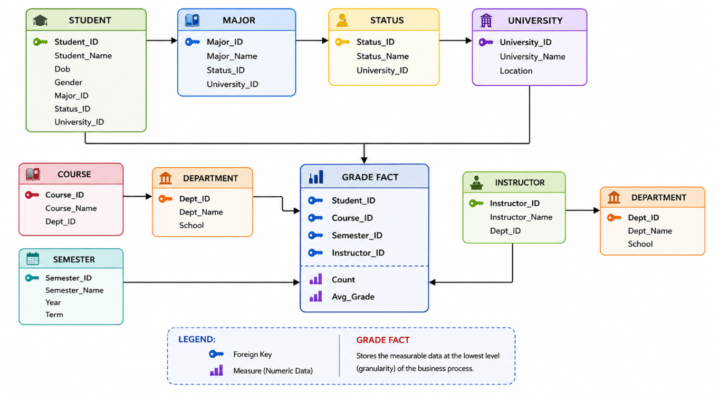
The fact table contains Student_ID, Course_ID, Semester_ID, Instructor_ID, Count, and Avg_Grade. The dimensions are normalized into additional related tables, making this a Snowflake Schema.

2(b). OLAP operations
Start with the base cuboid:
[student, course, semester, instructor]
Step 1 – Roll-up Semester to ALL:
[student, course, semester, instructor] → [student, course, ALL, instructor]
Step 2 – Roll-up Instructor to ALL:
[student, course, ALL, instructor] → [student, course, ALL, ALL]
Step 3 – Roll-up Course to Department:
[student, course, ALL, ALL] → [student, department, ALL, ALL]
Step 4 – Slice/Select the CS department:
[student, department = CS, ALL, ALL]
The final result gives the average grade of CS courses for each Big University student.
2(c). Number of cuboids
Each of the four dimensions has five levels, including ALL.
Number of cuboids = 5^4 = 5 × 5 × 5 × 5 = 625
Therefore, the cube contains 625 cuboids, including the base cuboid and apex cuboid.

Question 3. Data Warehouse for a Regional Weather Bureau
The weather bureau has about 1,000 probes collecting air pressure, temperature, and precipitation every hour. The data has been collected for more than 10 years from land and ocean locations.
A Star Schema is suitable because the measurements are numerical facts and the warehouse must support efficient querying and OLAP analysis.
Weather Fact Table
WEATHER_FACT
-------------------------
Time_ID
Probe_ID
Location_ID
Air_Pressure
Temperature
Precipitation
The grain of the fact table is one probe's weather measurement at one location for one hour.
Dimension Tables
1. TIME_DIMENSION: Time_ID, Hour, Day, Month, Quarter, Year
Hierarchy: Hour → Day → Month → Quarter → Year → ALL
2. PROBE_DIMENSION: Probe_ID, Probe_Name, Probe_Type, Installation_Date
3. LOCATION_DIMENSION: Location_ID, Location_Name, Land_Ocean, Region, Country
Hierarchy: Location → Region → Country → ALL
Weather Warehouse Schema Diagram
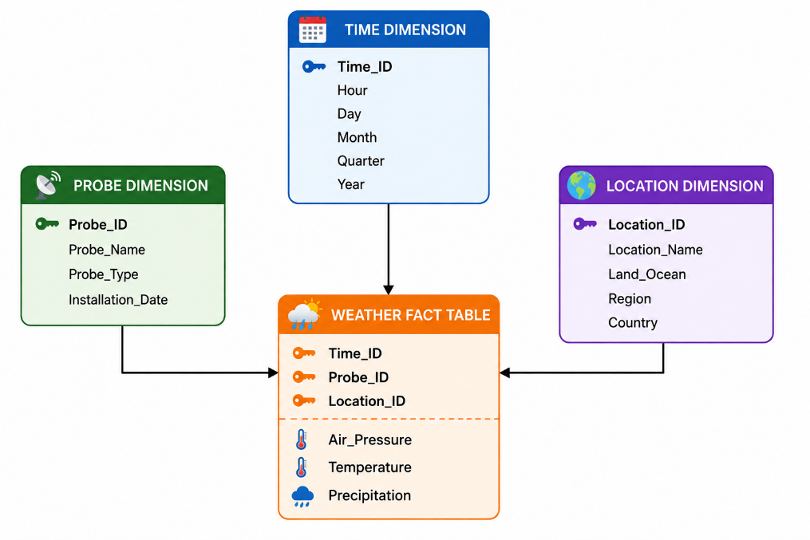
OLAP Operations Supported
Roll-up: Hour → Day → Month → Year, allowing yearly weather-pattern analysis.
Drill-down: Year → Month → Day → Hour, allowing detailed investigation of weather events.
Slice: Select a single year, such as Year = 2025.
Dice: Select multiple conditions, such as Temperature > 35°C, Region = Southern Region, and Year = 2025.
The design can answer questions about average temperature, precipitation, air pressure, land versus ocean conditions, and long-term weather patterns.

Question 4. Data Cube with n Dimensions and p Values
Given:
The data cube has n dimensions and each dimension has exactly p distinct values in the base cuboid. There are no concept hierarchies.

4(a). Maximum number of cells in the base cuboid
Each of the n dimensions has p values. Therefore:
Maximum base-cuboid cells = p^n
This occurs when every possible combination of dimension values exists.

4(b). Minimum number of cells in the base cuboid
The minimum occurs when only one combination of dimension values exists.
Minimum base-cuboid cells = 1

4(c). Maximum number of cells in the entire data cube
Each dimension can have p specific values or one ALL value. Therefore, each dimension has p + 1 possible positions.
Maximum cells in cube = (p + 1)^n
This includes base cells, aggregate cells, and the apex cell.

4(d). Minimum number of cells in the entire data cube
If the base cuboid contains only one cell, aggregation of that cell still produces one cell for every combination of a specific value or ALL across the n dimensions.
Minimum cells in cube = 2^n
For example, with n = 3, the minimum is 2^3 = 8 cells.

